Side menu
Home
├── About Us

├── Locations
│ ├── London
│ ├── Manchester
│ ├── Birmingham
│ └── View All Locations

├── Home Energy Upgrade Catalogue

├── News

├── Blog

├── FAQs

└── Contact

Homepage
- https://www.epccert.com/
- Canonical URL - https://www.epccert.com/
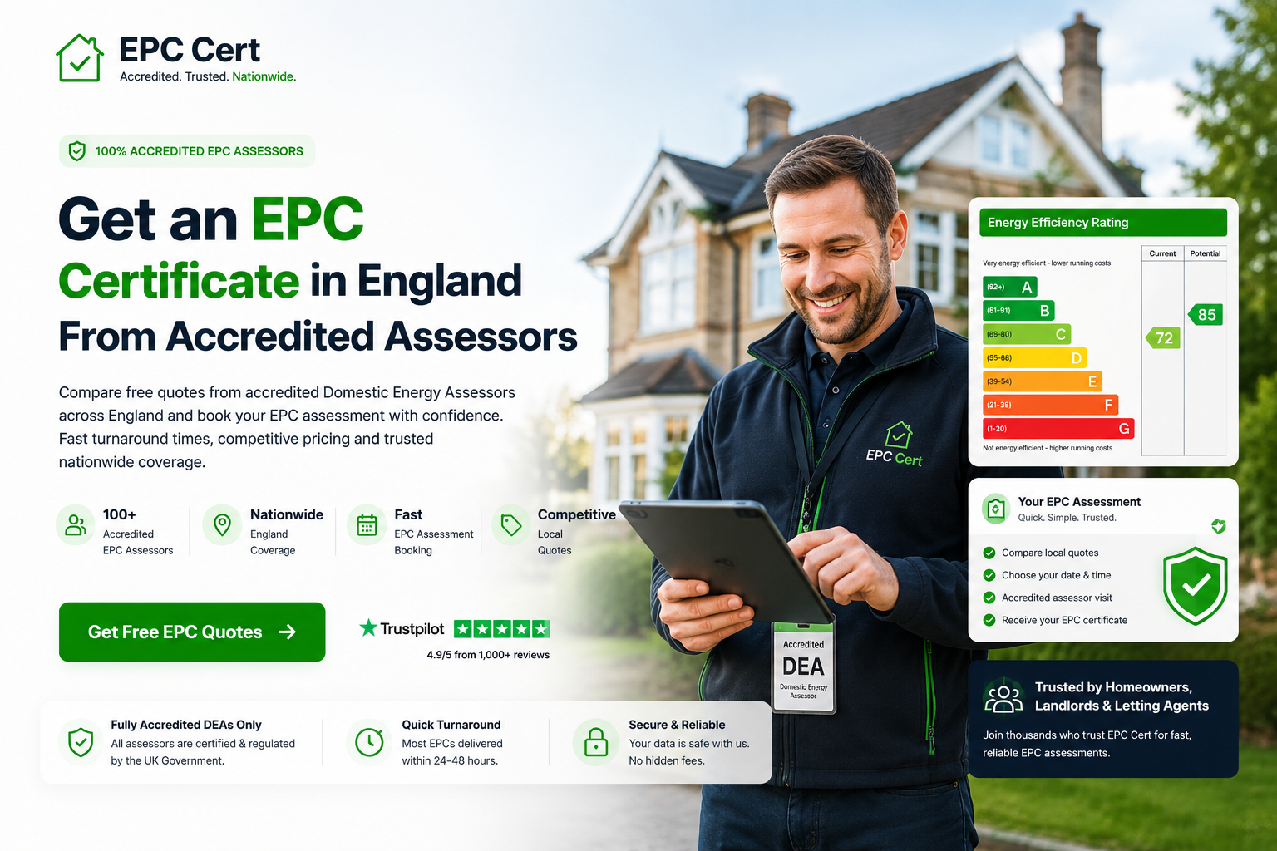
- Primary keyword -EPC Certificate England
- Secondary keyword - Energy Performance Certificate England, EPC Assessment England, Domestic EPC Certificate,
Commercial EPC Certificate
- Meta title - EPC Certificate England | Domestic & Commercial EPC
- Meta description - Book Accredited EPC Assessments Across England. Fast Domestic and Commercial EPC Certificates with Competitive Pricing and Nationwide Coverage
- Alt text - EPC Certificate England which provides a rating from A to G
Section 1-
- H1 - EPC Certificates Across England for Homes & Businesses
- Sub-heading - <p>Need an Energy Performance Certificate for a residential or commercial property? EPC Cert helps homeowners, landlords, estate agents, and businesses compare quotes from accredited assessors across England. Arrange a fast EPC assessment, choose a convenient appointment time, and receive a compliant certificate from an accredited assessor.</p>

Current | Recommended
100+ Assessors Across England | !00+ EPC Assessors Across England
Fully Accredited DEAs Only | Accredited Domestic & Commercial Assessors
Choose Your Date & Time | Flexible Appointment Times Available

- Current - Get the best quotes from local EPC Assessors today.
New - Arrange Your EPC Assessment with Accredited Assessors Across England

Section 2:
- Current h2- How it works
- New - h2- How to Arrange an EPC Assessment in England
- Current cards to be changed as per the table given below-
Step | Current | Recommended
01 | Select Date | Choose Your EPC Assessment Date
Supporting Text | Tell us your preferred date & time for the EPC assessment. | H3- Select a convenient date and time for your EPC assessment with an accredited assessor.
02 | Enter Details | Provide Property Details
Supporting Text | Share your property information in less than 1 minute. | H3- Enter key details about your residential or commercial property to receive relevant EPC quotes.
03 | Get Quotes | Compare Accredited EPC Quotes
Supporting Text | Receive competitive prices from local accredited DEAs. | H3- Compare quotes from accredited EPC assessors serving your area across England.
04 | Book Online | Confirm Your EPC Appointment
Supporting Text | Choose your preferred assessor and confirm instantly. | H3- Select your preferred assessor and book your EPC assessment online in minutes.

Section 3 -

Current | Recommended Copy
Why Homeowners Trust EPC Cert | Why Property Owners Across England Trust EPC Cert
Lowest Prices Guaranteed | H3- Compare Multiple Quotes and Save
Receive multiple quotes and choose the best option for you. | Compare quotes from accredited EPC assessors and choose the service that best fits your property and budget.
Accredited DEAs Only | H3- Accredited EPC Assessors Only
Every Domestic Energy Assessor is fully accredited and vetted. | Every assessor is accredited, vetted and qualified to carry out EPC assessments in England.
Money-Back Guarantee | H3- Local Assessors, National Coverage
We ensure you get a professional service or your money back. | Access a network of accredited EPC assessors serving homeowners, landlords and businesses across England.
Instant Online Booking | H3- Book Your EPC Assessment Online
No back-and-forth phone calls. Book everything in real-time. | Request quotes, compare assessors and confirm your EPC assessment online at a time that suits you.

Current | Recommendation
1k+ Homeowners Served | 1,000+ Property Owners Served
4.9/5 Average Rating | 4.9/5 Average Customer Rating
100+ DEA Assessors | 100+ Accredited EPC Assessors
Fast Turnaround | Fast Assessment Turnaround Times

Section 4:

Current | Recommended
Excellent | h2- Trusted by Property Owners Across England
Based on 1,000 verified customer ratings | <p> Based on verified reviews from homeowners, landlords and property professionals.</p>

- Keep the testimonials (no change)
- Current H3 - Are You a Domestic Energy Assessor?
- New H3 - Join Our Network of Accredited EPC Assessors
- Current - Register with epccert.com and receive local EPC job leads, straight to your phone.
- New sub-text - <p>Expand your reach by joining our network of accredited EPC assessors. Receive local assessment opportunities and connect with property owners across England.</p>
- Current CTA Button - Join Now (no change)
Section 5-
- Current H2- Find the Best Home Energy Partners
- New h2 - Improve Your EPC Rating with Trusted Energy Efficiency Specialists
- New Sub-heading - Access our curated network of trusted home energy specialists. From solar panel installers to insulation experts, find the right partner to improve your property's energy efficiency and support better EPC performance.
- Keep the buttons as it is.
- New image can be as below -
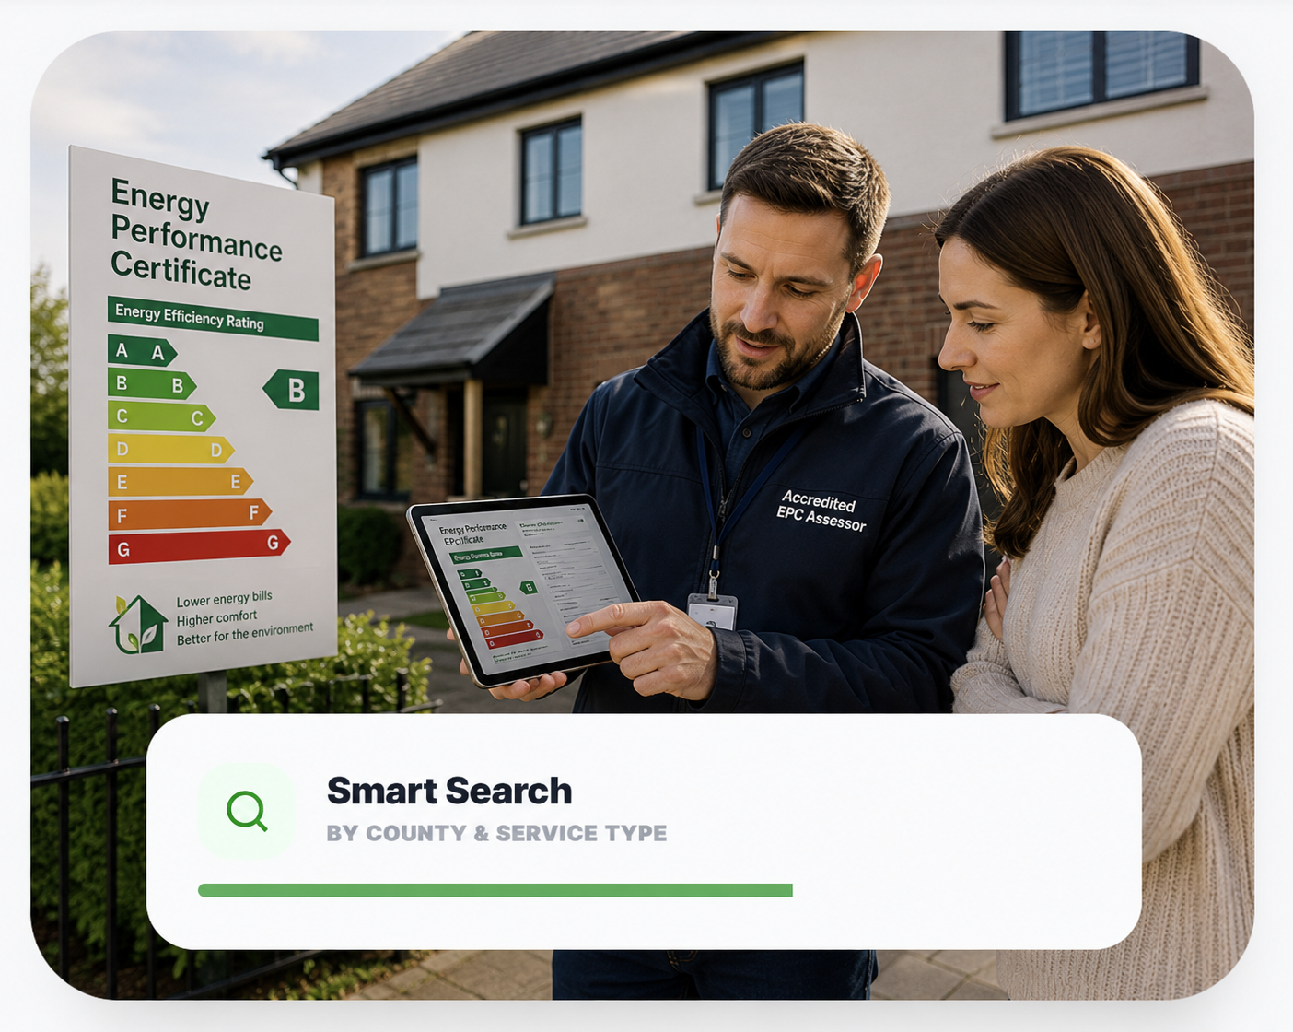
[Alt txt - Residential EPC assessment showing energy efficiency rating recommendations for a property owner - EPC Cert ]
Section 6-
- Current H2 - Frequently Asked Questions (no change)

FAQ Question | Answers
- H3- What is an EPC Certificate? | An EPC Certificate measures a property's energy efficiency and provides a rating from A to G. It also includes recommendations that may help improve energy performance.
- H3- When Do I Need an EPC Certificate in England? | An EPC is usually required when selling, renting or building a property in England. Property owners and landlords generally need a valid certificate before marketing a property.
- H3- How Much Does an EPC Assessment Cost? | EPC assessment costs vary depending on the property's size, type and location. Comparing quotes from accredited assessors can help you find the most suitable option.
- H3- How Quickly Can I Get an EPC Certificate? | Many EPC assessments can be arranged within a few days. Once the assessment is completed, the certificate is typically issued shortly afterwards.
- View all FAqs (no change )
Section 7-
- Current h2- Why Choose EPC Cert?
- New h2 - Why Arrange Your EPC Assessment Through EPC Cert?

 | Current Text | Icons | Recommendation
£ | Best Value Rates | 💬 (Quote/Comparison Icon) | H3- Compare Multiple EPC Quotes
⚡ | Quick Results | 📅 (Calendar Icon) | H3- Fast Assessment
🛡️ | Accredited DEA Experts | ✅ (Accreditation/Certificate Icon) | H3- Accredited EPC Assessors
✔️ | Smooth & Stress-Free | 💻 (Online Booking Icon) | H3- Simple Online Booking
🛡️ | Satisfaction Guaranteed | ⭐ (Trust/Review Icon) | H3- Trusted by Property Owners
🕒 | Pick Your Schedule | 🗓️ (Schedule/Clock Icon) | H3- Flexible Appointment Times
Section 8-
H2- EPC Assessments Across England
Sub-heading - Compare quotes from accredited EPC assessors serving homeowners, landlords and businesses across England.
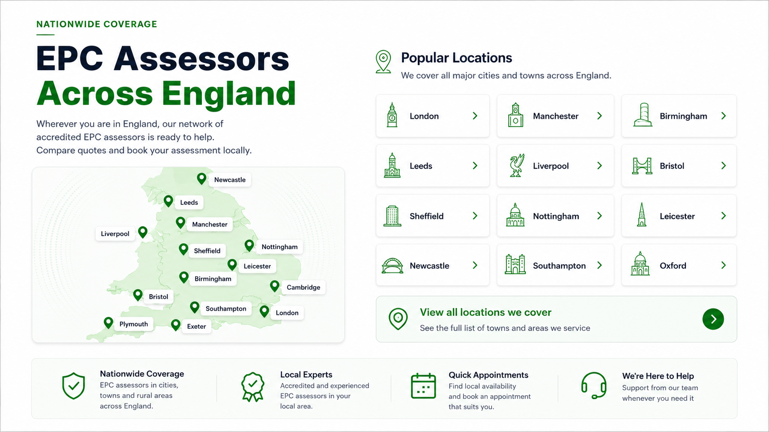
example-

Element | Recommendation
H2 | EPC Assessors Across England
H3 | Popular Locations
Card Text | London, Manchester, Birmingham etc.
City URLs | /epc-assessment-london/ etc
CTA | View All Locations We Cover
CTA URL | /locations/
Map | Keep

Section 9-
Remove this section


Schema

FAQs
- Current Page url - https://www.epccert.com/faq (redirect 301 old -new url)
- New url - https://www.epccert.com/epc-faq
- Canonical url - https://www.epccert.com/epc-faq
- Primary Keyword - EPC Certificate FAQ
- Meta title - EPC Certificate FAQ England | EPC Assessor
- Meta description - Find Answers to Common EPC Certificate Questions, Including Costs, Timelines, and Legal
- New H1 - Frequently Asked Questions About BER Certificates
Add the below not in table form.
FAQ Question | Answers
- H3- What is an EPC Certificate? | An EPC Certificate measures a property's energy efficiency and provides a rating from A to G. It also includes recommendations that may help improve energy performance.
- H3- When Do I Need an EPC Certificate in England? | An EPC is usually required when selling, renting or building a property in England. Property owners and landlords generally need a valid certificate before marketing a property.
- H3- How Much Does an EPC Assessment Cost? | EPC assessment costs vary depending on the property's size, type and location. Comparing quotes from accredited assessors can help you find the most suitable option.
- H3- How Quickly Can I Get an EPC Certificate? | Many EPC assessments can be arranged within a few days. Once the assessment is completed, the certificate is typically issued shortly afterwards.
- H3- How Long Is an EPC Certificate Valid? | An EPC Certificate is generally valid for 10 years. If the certificate has expired, a new assessment will usually be required.
- H3- Who Can Carry Out an EPC Assessment? | EPC assessments must be completed by a qualified and accredited energy assessor who is authorised to issue Energy Performance Certificates.

About page
- Current url - https://www.epccert.com/
- New url - https://www.epccert.com/about-us (301 redirect)

- Primary keyword - Energy Performance Certificate Experts
- Meta title - About EPC Cert | Energy Performance Certificate Experts
- Meta description - Learn about EPC Cert, trusted Energy Performance Certificate experts helping property owners across England arrange EPC assessments
- H1- Helping Property Owners Arrange EPC Assessments Across England
Sub-text - Expand to homeowners, landlords and businesses
- H2 - Our Story (no change )
- New sub-text -
<p>EPC Cert was established to receive Energy Performance Certificate (EPC) assessments easier for property owners, landlords, estate agents and businesses across England.
We understand that obtaining an EPC is often a necessary part of selling, renting or managing a property, yet finding a qualified assessor and arranging an appointment can be time-consuming. Our platform was created to simplify the process by connecting customers with accredited EPC assessors through a trusted nationwide network.
From residential homes and rental properties to commercial buildings, EPC Cert helps customers access professional EPC assessment services with greater convenience and confidence. We focus on providing a straightforward booking experience, flexible appointment availability and access to qualified assessors who operate in accordance with current EPC regulations and industry standards.
As energy efficiency continues to play an important role in the property sector, our commitment remains the same: helping customers across England access reliable EPC assessment services while making the process clear, efficient and stress-free.</p>

Current | Recommended
1k+ Completed EPC Assessments | Keep
100+ Accredited DEAs Nationwide | 100+ Accredited EPC Assessors Across England
Level 3 Qualified Energy Assessors | keep

Current | Recommended
HOW WE WORK | H2- How We Work
EPC CERT PRINCIPLES | <p>Our Core Principles</p>
- Cards recommendation-

Current Heading | Current Sub-Text | Recommended Heading | Recommended Sub-Text
SPEED & ACCURACY | We understand your time is valuable. Our assessors provide precise ratings with a focus on fast turnaround. | H3- Professional Service | <p>Accredited assessors deliver reliable EPC assessments with clear reporting and efficient turnaround times.</p>
EXPERT INTEGRITY | All assessments are handled by fully insured and registered professionals committed to honest reporting. | H3- Accredited Assessors | <p>We work with qualified EPC assessors committed to professional standards and impartial assessments.</p>
GREEN FUTURE | We provide recommendations aimed at long-term energy savings and environmental impact reduction. | H3- Energy Efficiency Focus | <p>EPC assessments help property owners understand energy performance and identify improvement opportunities.</p>
- Current h2- Join EPC Cert
- New H2- Need an EPC Certificate?
- Sub-text- Compare quotes from accredited EPC assessors serving homeowners, landlords and businesses across England.
- New Button text - Get a Free Quote (link to be added - /contact-us)

contact-us
- Page URL - https://www.epccert.com/contact-us
- Canonical URL - https://www.epccert.com/contact-us
- Primary keyword - Book EPC Assessment England
- New H1 -Book an EPC Assessment in England
- New sub-text - Compare quotes from accredited EPC assessors across England and arrange your EPC assessment with confidence.
- Meta title - Book EPC Assessment England | Contact EPC Cert
Meta description - Book an EPC assessment in England with accredited assessors. Contact EPC Cert to compare quotes and arrange your EPC today
Current new
 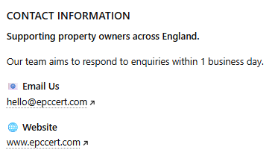

- Keep the form field same

Current | Recommended
SEND US A DETAILED MESSAGE | H2: Request a EPC Assessment
Tell us more about your request... | Tell us about your property or EPC assessment requirements.
Send Message | H2: Submit Enquiry

Catalogue
- Current Url - https://www.epccert.com/catalogue
- Canonical url - https://www.epccert.com/catalogue
The page contains two datasets:
- Energy Professionals
- EPC Assessors
1. Main url - https://www.epccert.com/catalogue

- Primary keyword - EPC Assessor Directory England
- Secondary Keywords-
- EPC Assessor Directory England
- Accredited EPC Assessors England
- Domestic Energy Assessors England
- Commercial EPC Assessors England
- Energy Assessment Professionals England
- EPC Services England
- Meta title - EPC Assessors Directory England | EPC Cert
- Meta description - Browse accredited EPC assessors across England. Search by location, property type and assessment requirements to find qualified professional
- H1 - England's EPC Assessors Directory
- Intro para -
The EPC Cert Directory helps homeowners, landlords, estate agents, and businesses connect with accredited EPC assessors across England. Browse professionals providing domestic EPC certificates, commercial EPC assessments, and property energy performance services. Search by location, property type, or assessment requirement to find qualified assessors serving your area.
- Energy Professionals page -
- New URL - https://www.epccert.com/catalogue/epc-assessors
- Canonical URL - https://www.epccert.com/catalogue/epc-assessors
- Primary keyword - EPC Assessors England
- Meta title -Find EPC Assessors Across England | EPC Cert
- Meta description- Directory of accredited EPC assessors across England covering residential and commercial Energy Performance Certificate assessments
- H1- EPC Assessors Across England

- Business page - https://www.epccert.com/catalogue/epc-businesses
- Canonical URL - https://www.epccert.com/catalogue/epc-businesses
- Primary keyword - Home Energy Service Providers England
- Meta title - Home Energy Professionals England | EPC Cert Directory
- Meta description - Connect with home energy professionals across England, including EPC assessors, energy consultants and property energy specialists
- H1- Home Energy Service Providers England

hire agent
- Current url - https://www.epccert.com/hire-agent
- Canonical url - https://www.epccert.com/hire-agent
- Primary keyword - Energy Advisor England
- Meta title - Energy Advisor England | Independent Home Energy Advice
- Meta description- Receive independent energy advice, upgrade guidance and technical support to help improve your property's energy performance
- H1- Independent Energy Advice for Homeowners Across England
- Sub-text - Make informed home energy upgrades with EPC expert advice, technical insights, and support tailored to your property's needs.
- H2 - SPEAK TO AN ENERGY ADVISOR
- Sub-heading- Your Energy Advisor works alongside accredited EPC assessors to help you understand upgrade options, compare quotes and make informed decisions for your property.
- No change in - The agent will then: the bullet points
- New line - The goal is to provide clear guidance, verified technical input, and access to competitive pricing, ensuring upgrades are completed as smartly and economically as possible.
- Independent from contractors Technical input & certification (no change)

- The form remains same as contact us page form

blog
- Current url - https://www.epccert.com/blog
- Canonical - https://www.epccert.com/blog
- Primary keyword - EPC Insights England
- Meta title - EPC Insights & Energy Efficiency Guides England | EPC Cert
- Meta description - Explore EPC guides, energy efficiency advice, property energy insights and expert resources to help homeowners, landlords and businesses across England
- H1 - EPC Insights & Energy Efficiency Guides England
- Sub-text - Stay informed with expert insights on Energy Performance Certificates, energy efficiency, property energy ratings and home improvement opportunities across England. Explore practical guides, industry updates and professional advice designed to help homeowners, landlords and businesses make informed property energy decisions.

News
- Page url - https://www.epccert.com/news
- Canonical url - https://www.epccert.com/news
- Primary keyword - EPC Regulation Updates England
- Meta title - EPC Regulation Updates England | Industry News & Changes
- Meta description - Follow the latest EPC regulation updates, compliance changes, government announcements and industry news across England
- H1- EPC Regulation Updates & Industry News England

Locations
- Page url -https://www.epccert.com /locations/
- Canonical url - https://www.epccert.com/
- Primary keyword- EPC Assessors Across England
- Meta title - EPC Assessors Across England | Service Areas
- Meta description-Connect with accredited EPC assessors serving homeowners, landlords and businesses across England. View local service areas and coverage.
- H1- EPC Assessors Across England

Sub-heading - Compare quotes from accredited EPC assessors serving homeowners, landlords and businesses across England.

example-

Element | Recommendation
H2 | EPC Assessors Across England
H3 | Popular Locations
Card Text | London, Manchester, Birmingham etc.
City URLs | /epc-assessment-london/ etc
CTA | View All Locations We Cover
CTA URL | /locations/
Map | Keep

Page | Primary Keyword
Locations Hub | EPC Assessors Across England
London Page | EPC Assessment London
Manchester Page | EPC Assessment Manchester
Birmingham Page | EPC Assessment Birmingham

Notes
- Schema makeup not added as social media page urls not available
- Required - facebook and instagram page urls
- For Local SEO schema need the office address
- Core- web vitals improvements follow the same as The Ber Man

